Calculated Columns
1.Create a Calculated Column for 'Category Type'
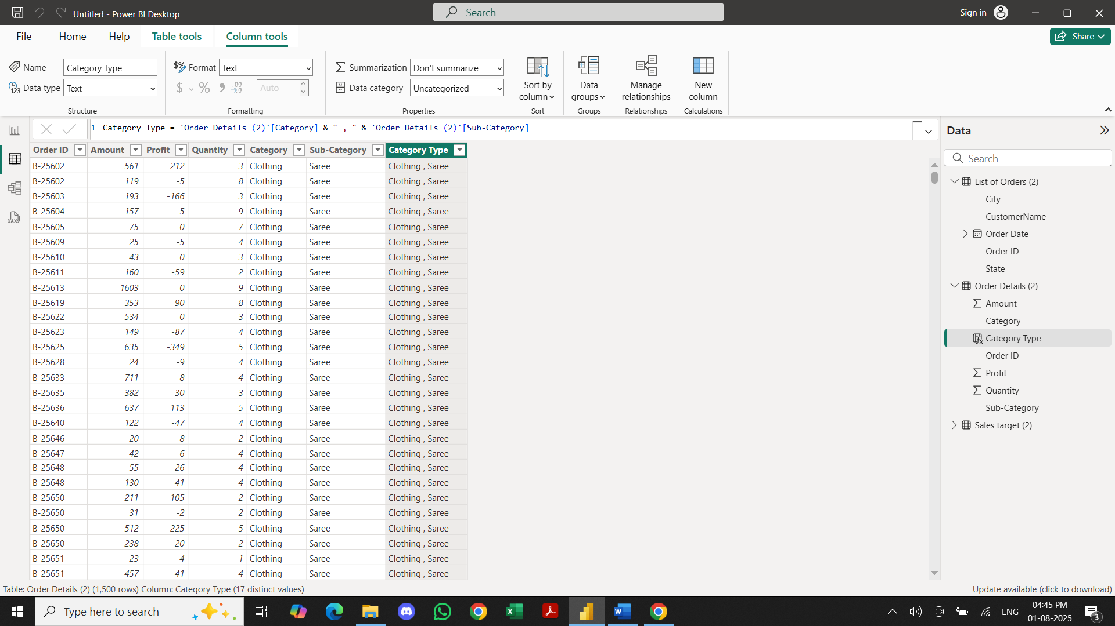

2.Calculate Revenue per Order in Order Details Table
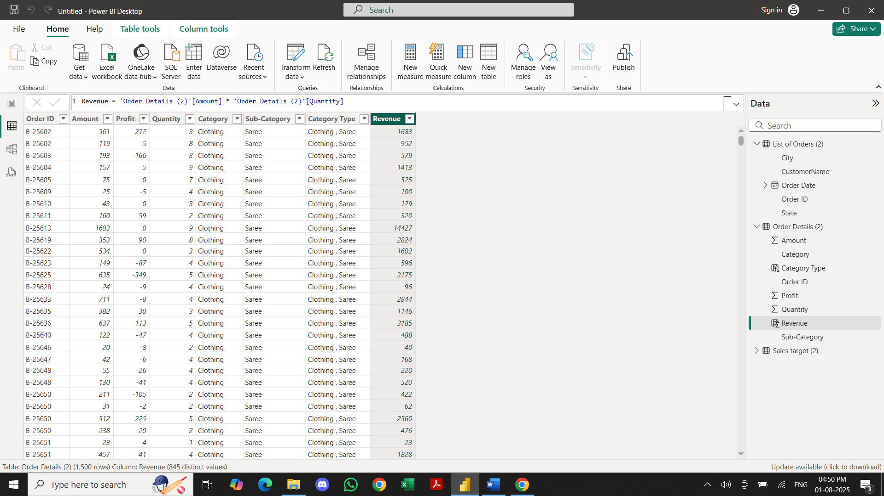

3. Create a Calculated Column to Categorize Sales
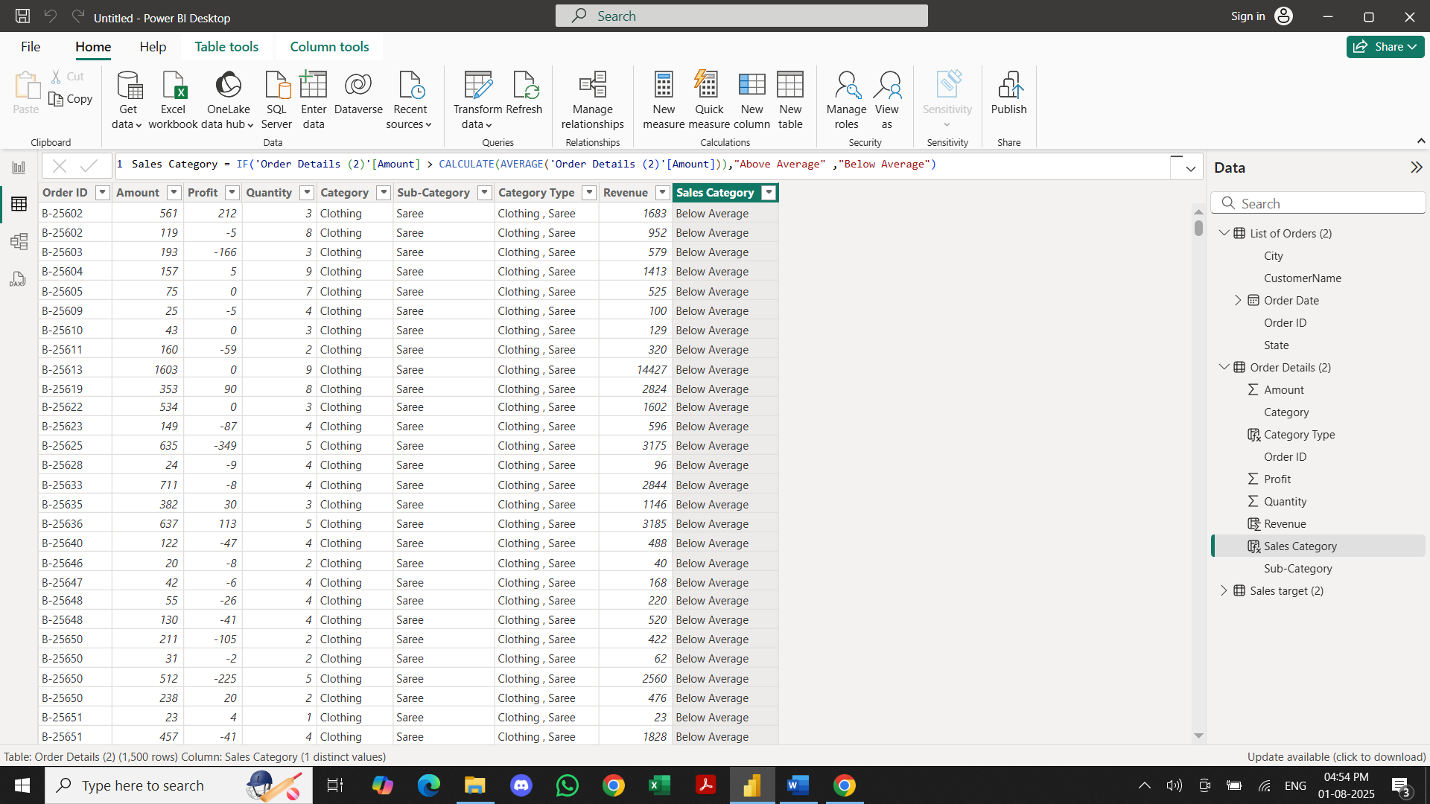

Calculated Measures
1.Calculate Order Count
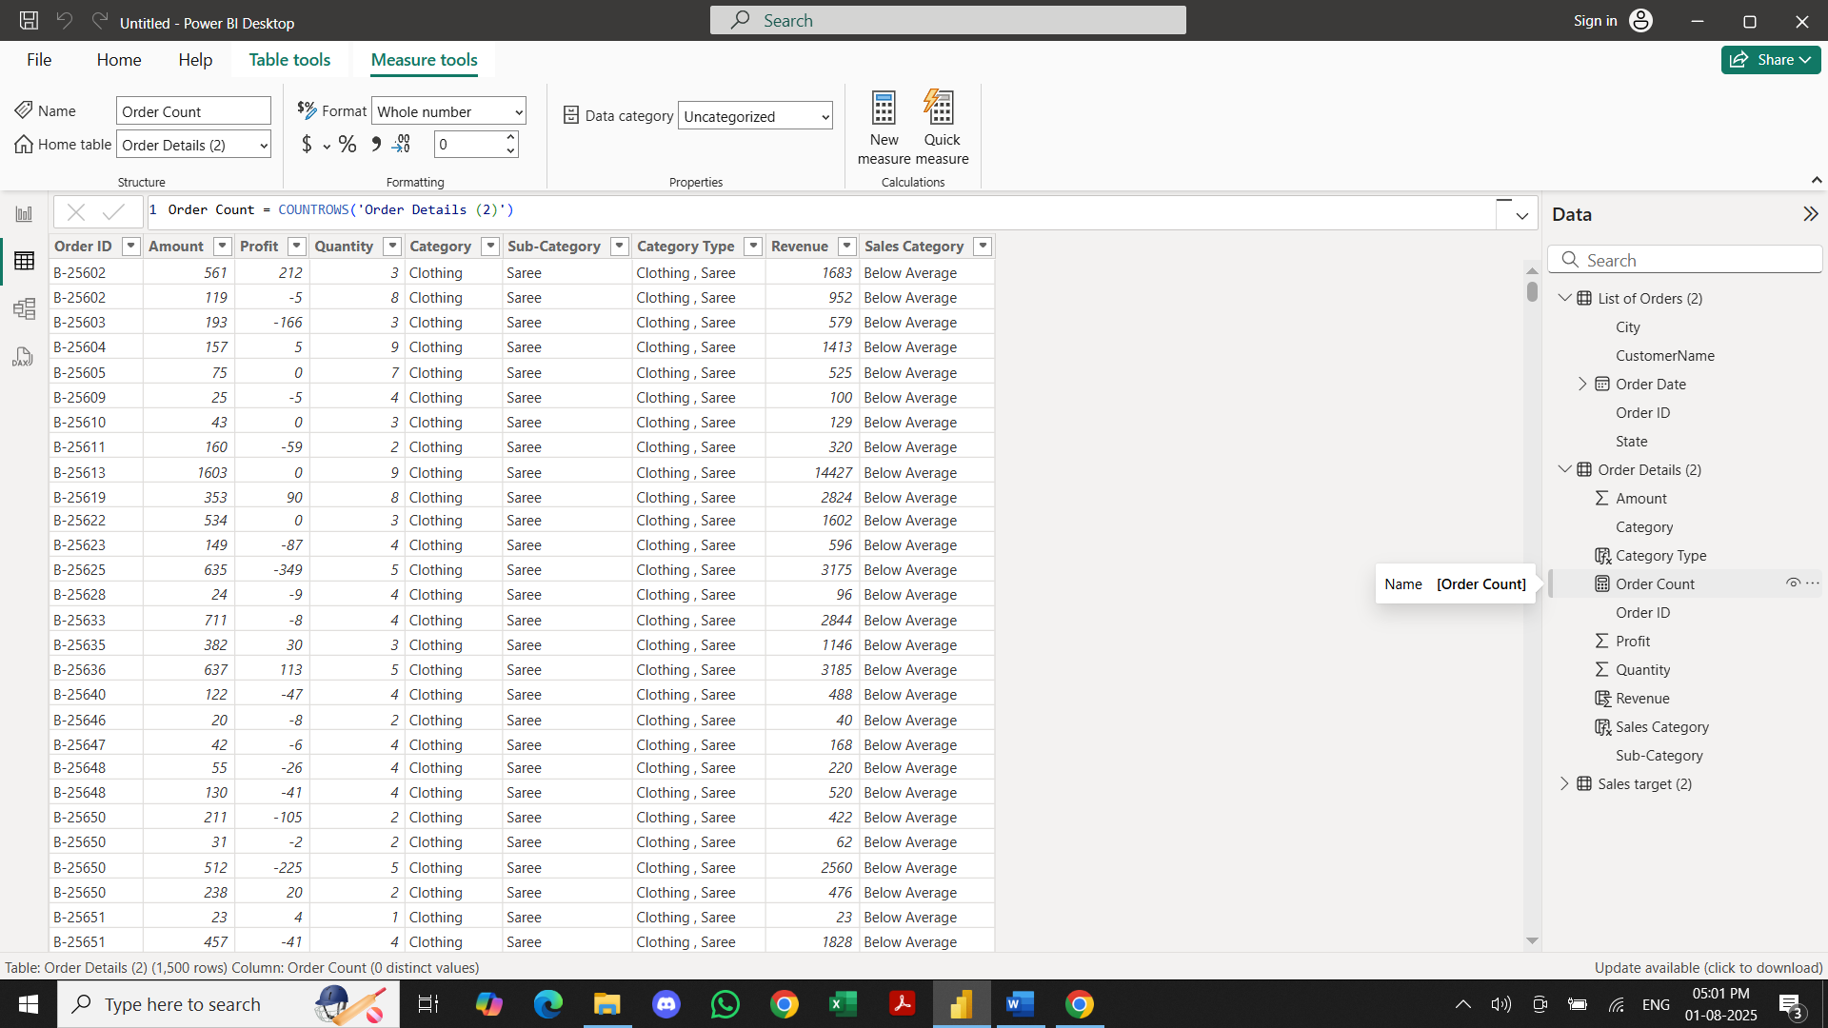
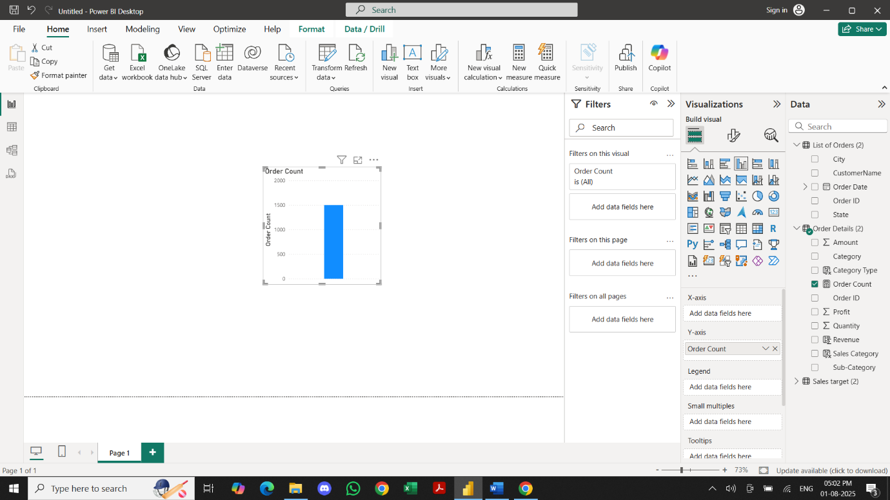

2.Calculate Average Profit in Delhi
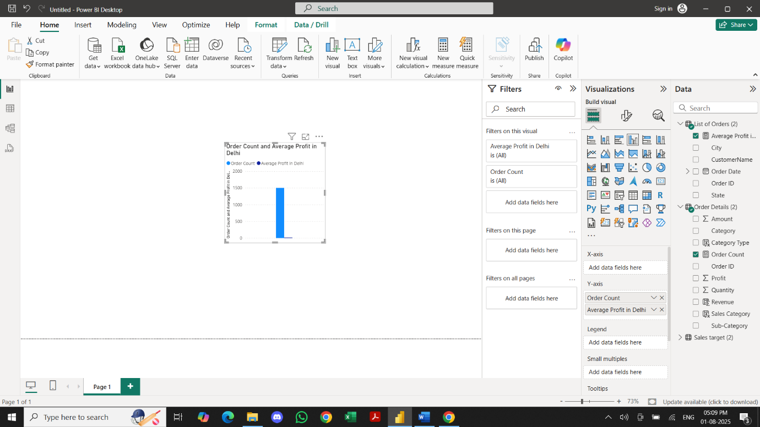

3. Calculate Year-to-Date (YTD) Sales

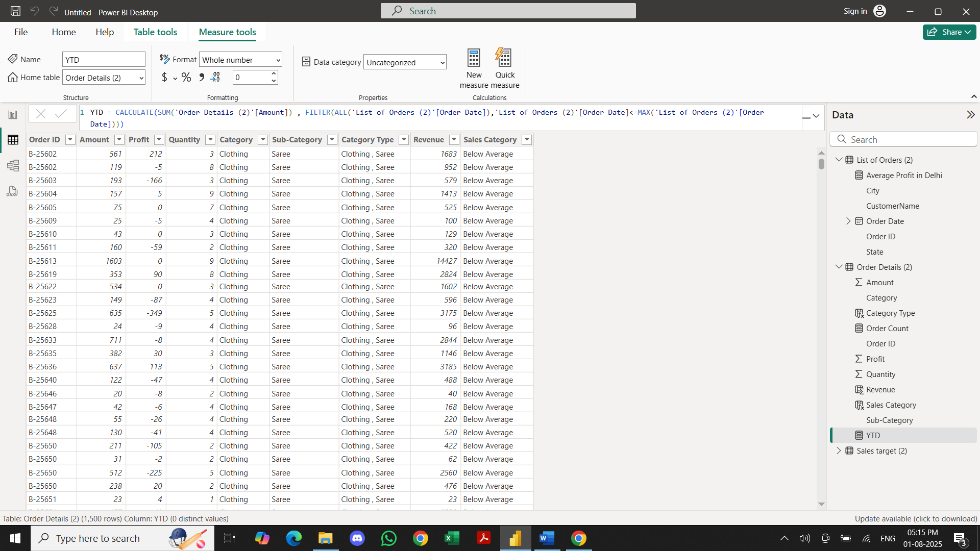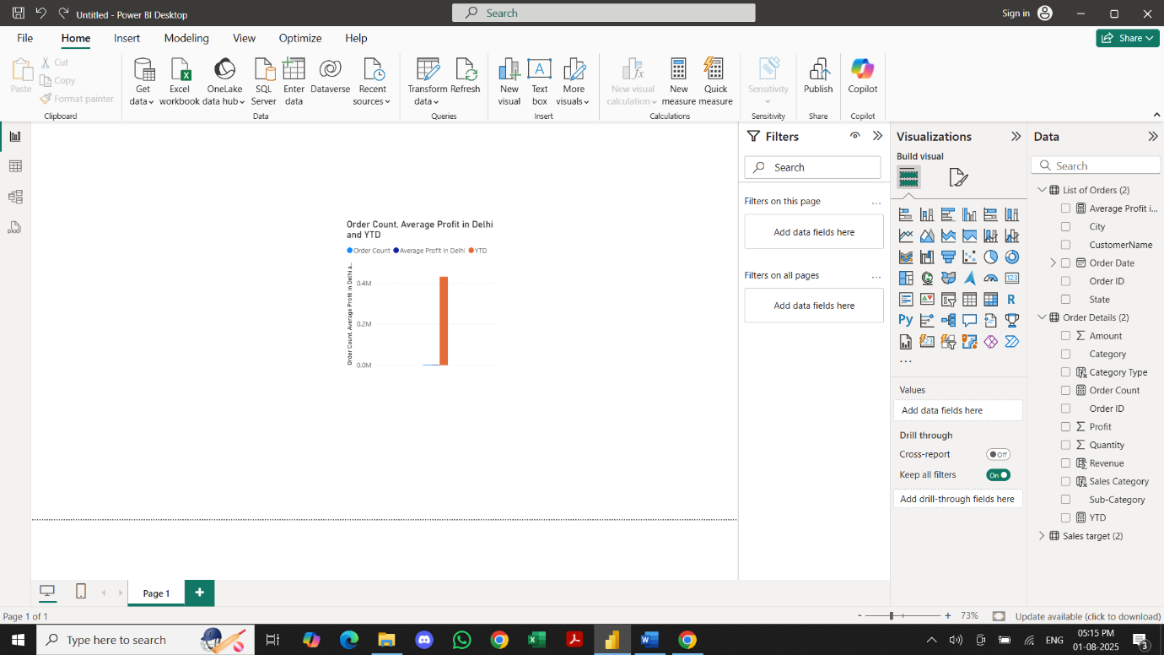

Data Visualization
Sales Target Achievement by Category:
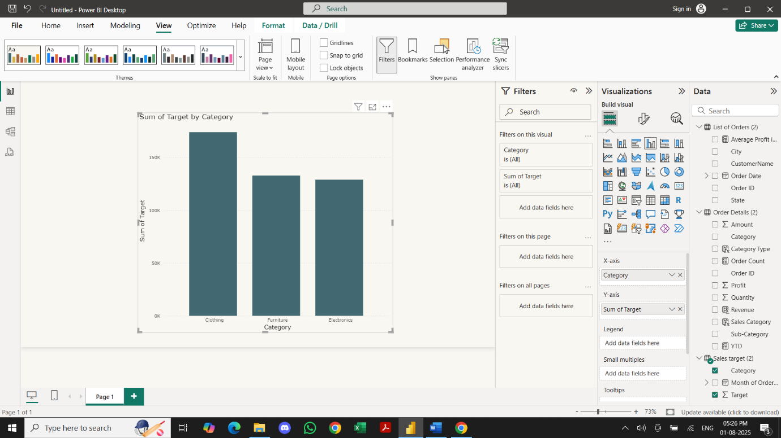

Max Profit Margin by Sub-Category
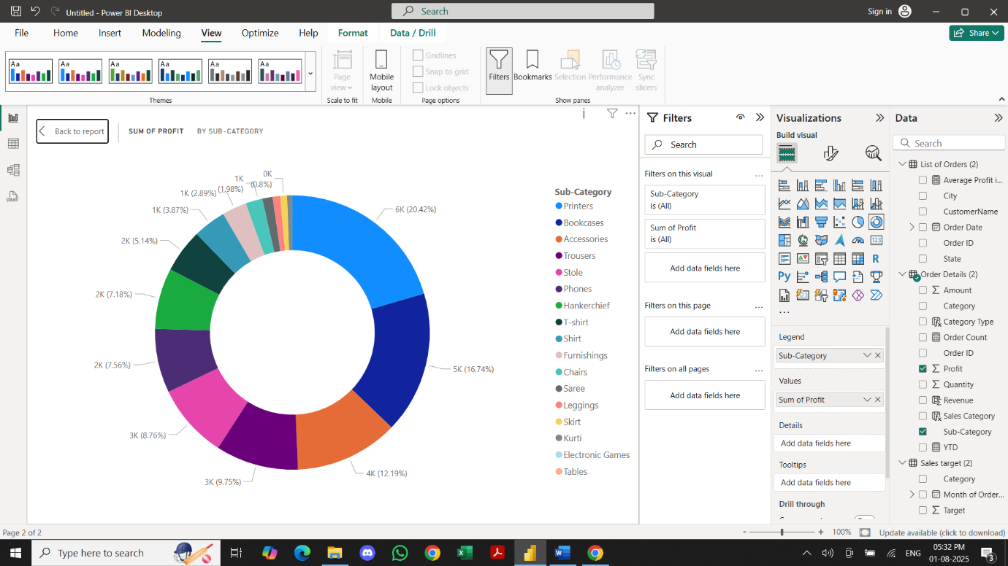

Monthly Sales Trend
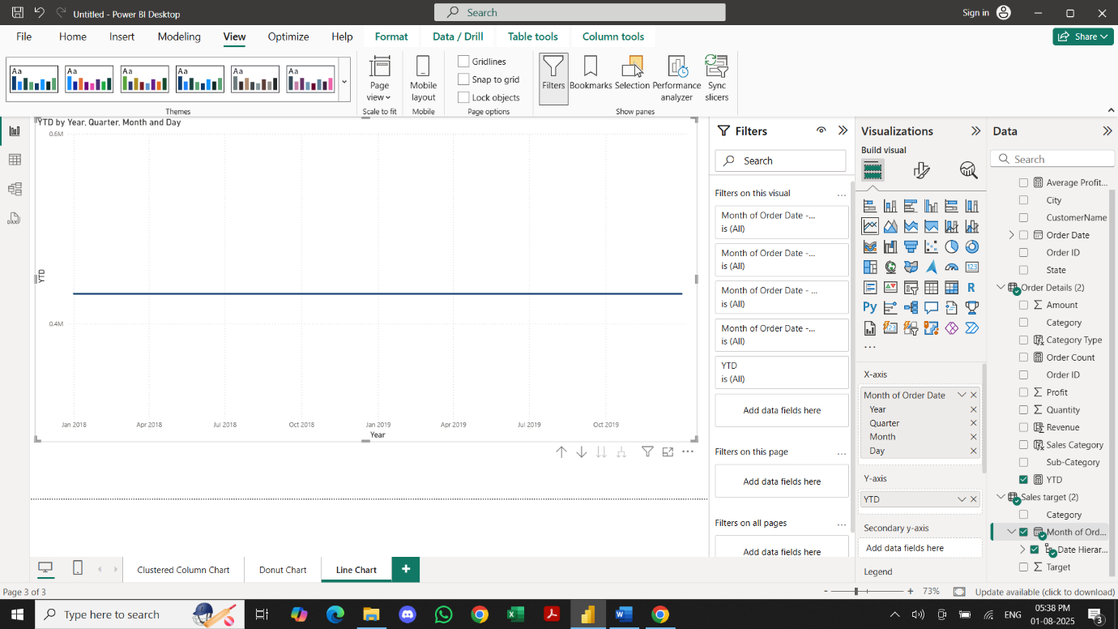

Comparison of Profit and Quantity by Sub-Category
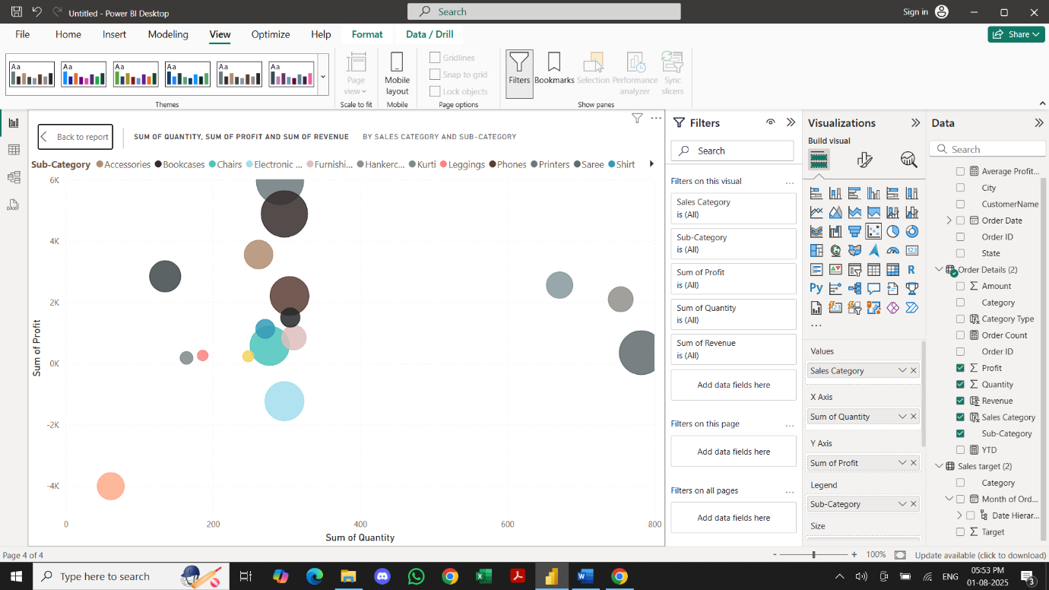

Comparison of Total Sales Amount and Target
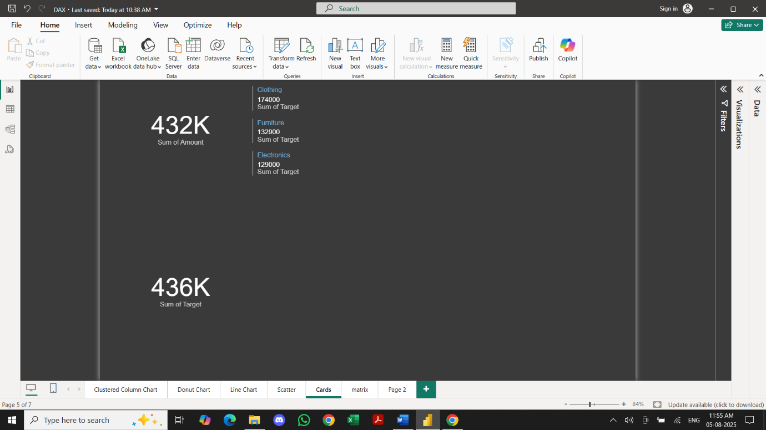

Sales Performance Matrix
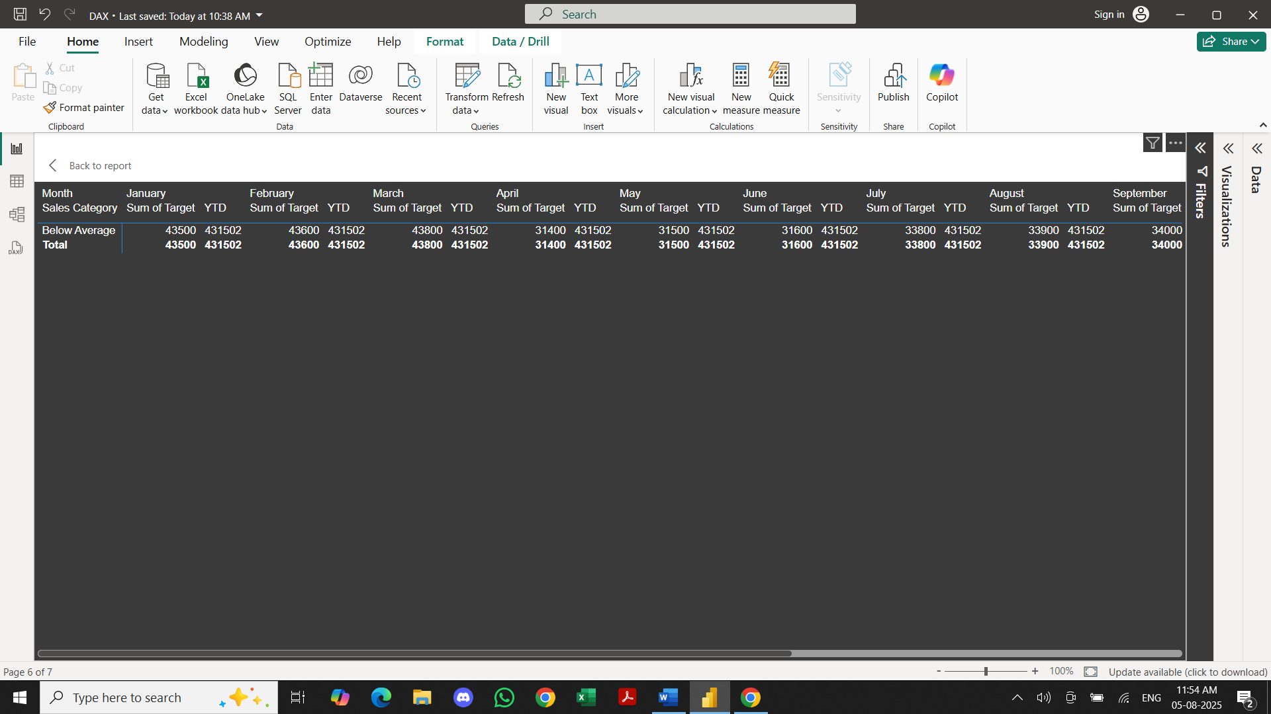

Sales Distribution by Sub-Category
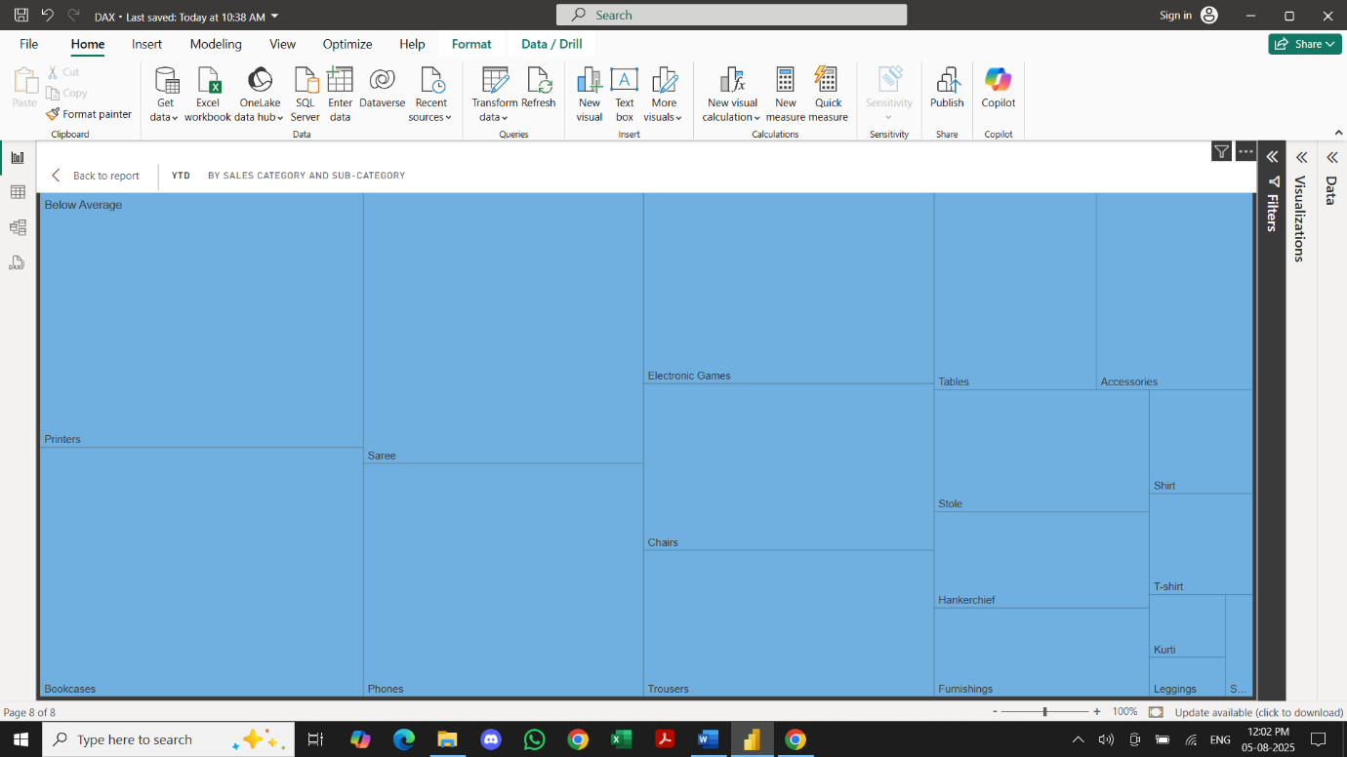

Order Count Analysis by State
